**Practical no 1 Aim:** Write a program to demonstrate bitwise operation. **Code:**

public class Test {

public static void main(String args[]) { int a = 60;

int b = 13; int c = 0; [c = a & b;](https://e-next.in/)

[System.out.println("a & b = " + c );](https://e-next.in/) [c = a | b;](https://e-next.in/)

[System.out.println("a | b = " + c );](https://e-next.in/)

c = a ^ b;

System.out.println("a ^ b = " + c ); c = ~a;

System.out.println("~a = " + c ); c = a << 2;

System.out.println("a << 2 = " + c ); c = a >> 2;

System.out.println("a >> 2 = " + c ); c = a >>> 2; /* 15 = 0000 1111 */

System.out.println("a >>> 2 = " + c );

}

}

# Output:

**Practical No.3**

**Aim:-** Implement Dynamic programming algorithm for computing theedit distance between

# Code:

public class EditDistanceProblem

{

public int editDistanceRecursion(String s1,String s2,int m,int n)

{

if(m==0)

return n; [if(n==0)](https://e-next.in/)

[return m;](https://e-next.in/)

[if(s1.charAt(m-1)==s2.charAt(n-1))](https://e-next.in/)

[return editDistanceRecursion(s1,s2,m-1,n-1);](https://e-next.in/)

return 1 + Math.min(editDistanceRecursion(s1, s2, m, n-1 ), Math.min(editDistanceRecursion(s1, s2 , m-1 , n ),

editDistanceRecursion(s1 ,s2 , m-1 , n-1) ) );

}

public static void main(String[] args)

{

String s1 = "horizon"; String s2 = "horizontal";

EditDistanceProblem ed = new EditDistanceProblem(); System.out.println("Minimum Edit Distance - (Recursion): " +

ed.editDistanceRecursion(s1,s2,s1.length(),s2.length() ) );

}

}

# Output:

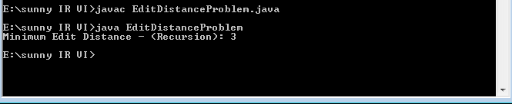

**Practical No.7**

**Aim:-** Write a program for Pre-processing of a Text Document: stopword removal.

# Stopwords1.py:-

>>> import nltk

>>> from nltk.corpus import stopwords

>>> set(stopwords.words('english'))

# Output:-

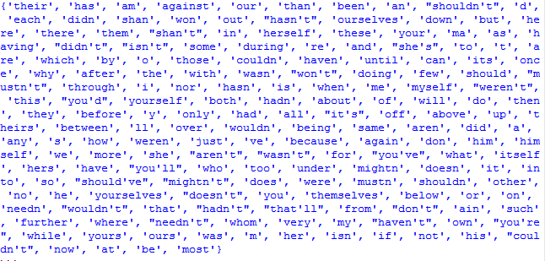

**Stopwords1.py:-**

fromnltk.corpus import stopwords fromnltk.tokenize import word_tokenize

example_sent = "This is a sample sentence, showing off the stop words filtration."

stop_words = set(stopwords.words('english')) word_tokens = word_tokenize(example_sent)

filtered_sentence = [w for w in word_tokens if not w in stop_words] filtered_sentence = []

[for w in word_tokens:](https://e-next.in/)

[if w not in stop_words:](https://e-next.in/)

[filtered_sentence.append(w)](https://e-next.in/)

[print(word_tokens)](https://e-next.in/) [print(filtered_sentence)](https://e-next.in/) **Output:-**

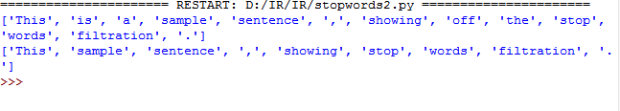

# Practical No.8

**Aim:-** Write a program for tkinter.

# Code:

from tkinter import * root=Tk()

l1=Label(root,text="Enter Number 1:") l1.pack()

t1=Entry(root,bd="3") t1.pack()

l2=Label(root,text="Enter Number 2:")

[l2.pack()](https://e-next.in/) [t2=Entry(root,bd="3")](https://e-next.in/) [t2.pack()](https://e-next.in/)

def addNumber(): a=int(t1.get())

b=int(t2.get()) c=a+b

print("Addition of two NOS:",C)

b1=Button(root,text="Addition",fg="red",bg="green",command=addNumber) b1.pack() root.mainloop()

# Output:-

